


Do you have a problem with your phone or internet service?

How we can help

Easy Read version

How to use this document


The Telecommunications Industry Ombudsman (TIO) wrote this document. When you see the word ‘we’, it means the TIO.


We wrote this information in an easy to read way. We use pictures to explain some ideas.


We have written some words in bold.

This means the letters are thicker and darker.

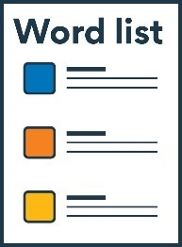
We explain what the bold words mean. There is a list of these words on page 18.

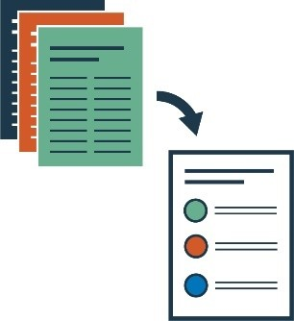
This Easy Read document is a summary of another document. This means it only includes the most important ideas.


You can ask for help to read this document. A friend, family member, or support person may be able to help you.

What’s in this document?
What we do 4

How we help 7

Making a complaint 13

Support to make a complaint 15

Word list 18

Contact us 20

What we do

At TIO, we help people who have a complaint

about their:

- phone service


- internet service.


A complaint is when you tell someone about:

- something that has gone wrong


- a problem you want fixed.

Our services are:

- free

independent.


This means we:

- don’t ask you to pay for our help


- aren’t controlled by companies who provide internet or phone services


- don’t take sides.

We can help you with:

- your personal phone or internet services


- phone or internet services you use in a small business.

How we help

Contract complaints

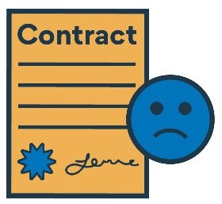
We can help you with a complaint about your contract.


A contract is an agreement between you and your phone or internet provider.


A contract includes:

- what the provider needs to do


- what the provider will give you


- what you need to do.

You can make a complaint if you agreed to something with your provider but:

- you didn’t get it


- you didn’t need it


- you don’t have money to pay for it


- they didn’t provide it.




Bill complaints
For example, you thought you had signed up for up to 10GB of data on a mobile phone plan.

But you found out you only have 3GB of data.


We can help you with a complaint about your phone or internet bill.


A bill tells you how much you need to pay for your phone or internet service.


You can make a complaint if you think there is something wrong with your bill.


We can also help if you are having trouble paying your bill.

Other complaints

We can help you if you have a complaint about:


- someone who sold you a phone plan that you can’t pay for


- your phone or internet service not working as it should


- your provider stopping your phone or internet service.

Debt collection


Debt is when you owe money.


You can owe money to a:

- person

- company


- bank.

Debt collection is when you are asked to pay the money back.


We can help you if your phone or internet provider asks you to pay a debt that isn’t yours.

Making a complaint


Before you come to us, you need to try and fix the problem with your phone or internet provider first.


You can contact them to make a complaint.


If you can’t fix the problem with your provider, then you can contact us.


We will decide if we can deal with your complaint.


We will let you know what we decide.


If we can, we will work with you and the provider to fix the problem.


If you and the provider can’t agree, we may work out how to solve the complaint for you.


Support to make a complaint

You can ask someone to make a complaint for you.

You could ask a:


- friend


- family member


financial counsellor.

A financial counsellor helps you with money. They can:

- give you information


- give you advice



- support you if you are having trouble with money.

You will need to authorise the person to make a complaint for you.


When you authorise something, you say it is ok for the person to do it.


You may need to sign a form to authorise the person.

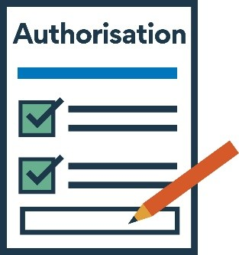
This form is called the
‘Authorisation of representatives form’.


You can ask us for the form.


Or you can find the form on our website.
Word list

This list explains what the bold words in this document mean.

Authorise

When you authorise something, you say it is ok for someone to do it.

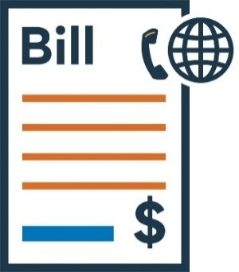
Bill

A bill tells you how much you need to pay for your phone or internet service.


Contract

A contract is an agreement between you and your phone or internet provider.

Debt

When you owe money.

Debt collection

When you are asked to pay the money back.

Financial counsellor


A financial counsellor helps you with money. They can:
- give you information

- give you advice

- support you if you are having trouble with money.


Independent

This means we:

- don’t ask you to pay for our help

- aren’t controlled by companies who provide internet or phone services
- don’t take sides.

Contact us


1800 062 058


1800 630 614



www.tio.com.au

PO Box 276

Collins Street West, Melbourne, VIC 8007
If you speak a language other than English, you can call:
Translating and Interpreting Service (TIS)

131 450



The Information Access Group created this Easy Read document using stock photography and custom images. The images may not be reused without permission. For any enquiries about the images, please visit www.informationaccessgroup.com. Quote job number 3701.

